**Lab Practical #04:**

Installation of Network Simulator (Packet Tracer) and Implement different LAN topologies.

**Practical Assignment #04:**

1. **Create a simple network with switch and two or more pc. Also check connectivity between them using ping command or PDU utility.**
2. **Implement different topologies in packet tracer.**
   1. **Bus**
   2. **Ring**
   3. **Star**
   4. **Mesh**
   5. **Tree**

**Instructions:**

1. Topology-wise Screenshot.
2. Mention IP address of each pc as label.
3. Ping command or PDU screenshot between two pcs.

**Bus Topology**

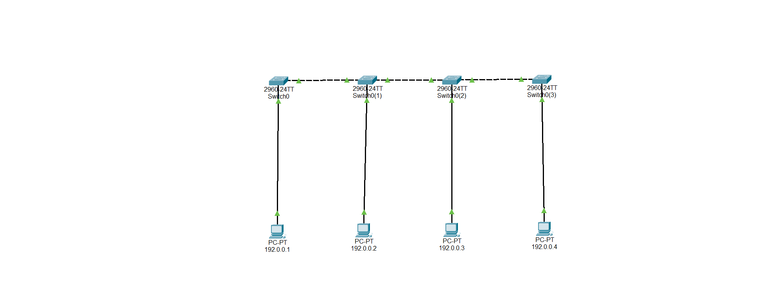

**Bus Topology - Simulation**

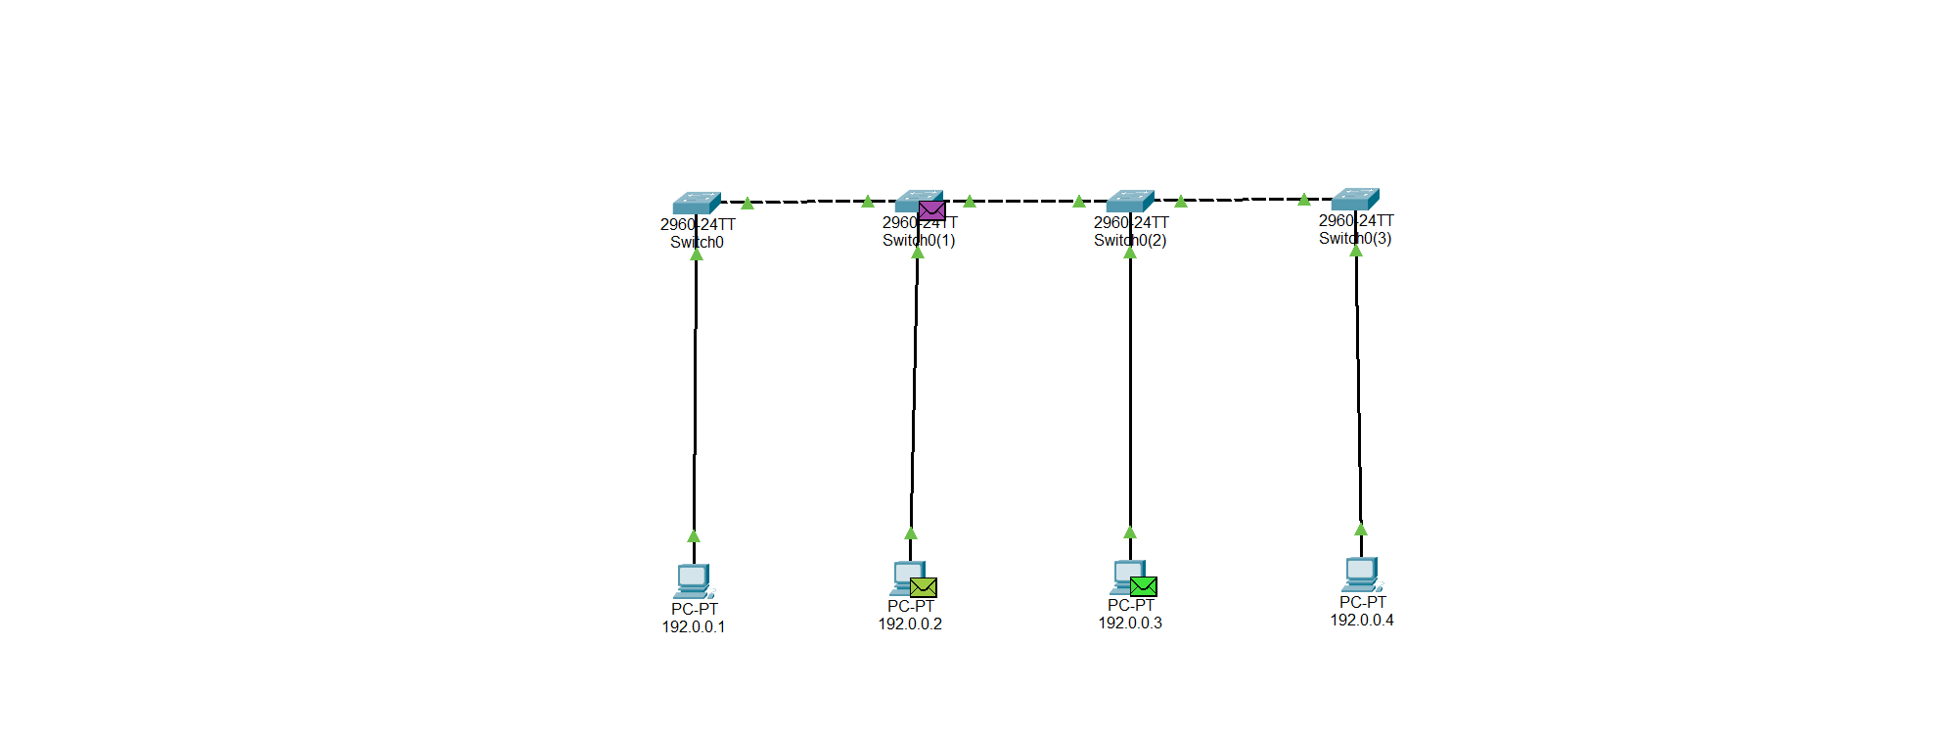

**Ring Topology**

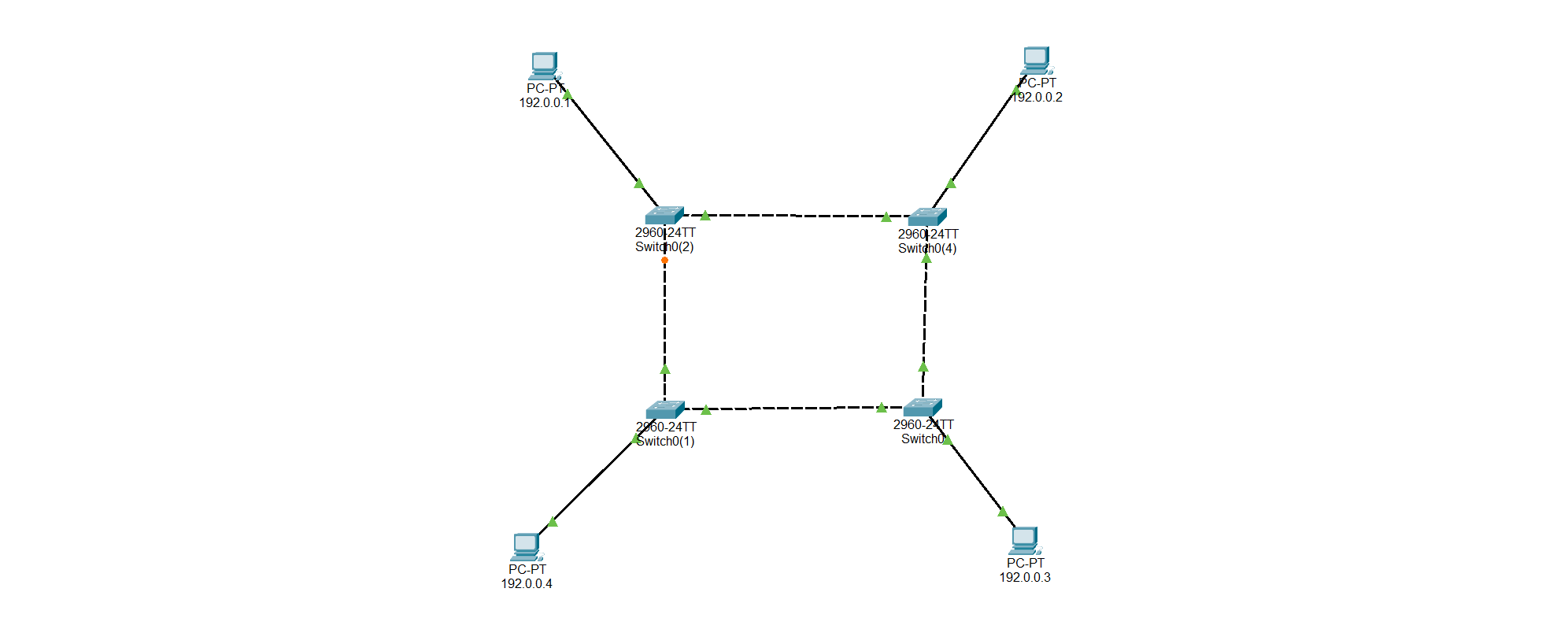

**Ring Topology – Simulation**

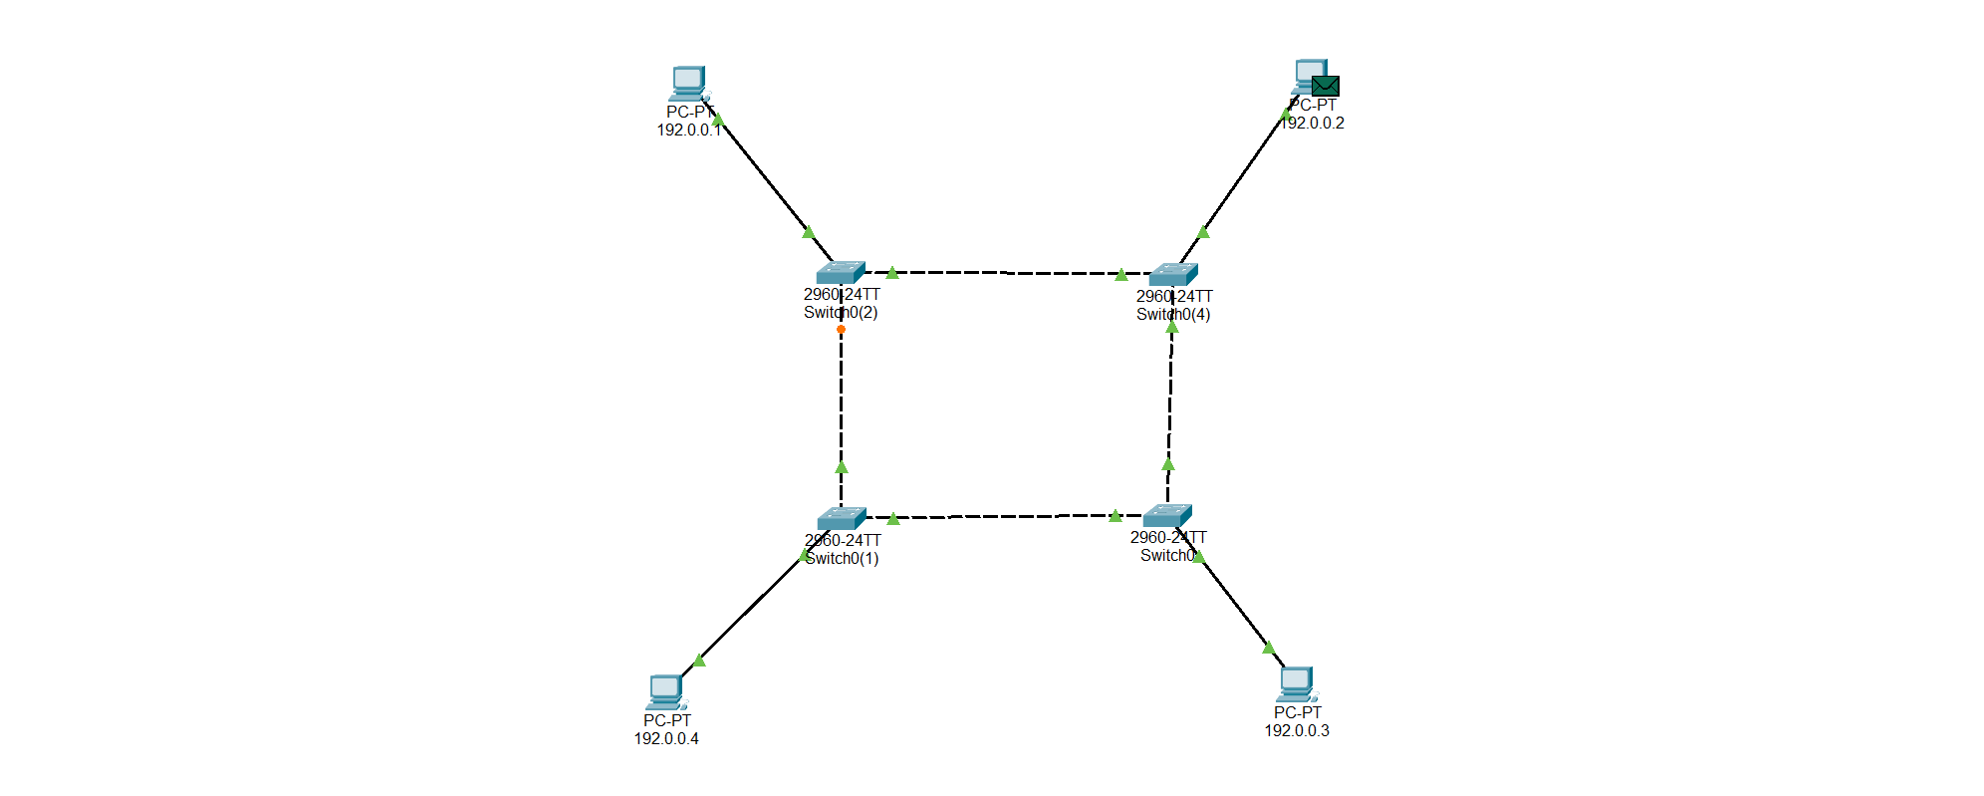

**Star Topology**

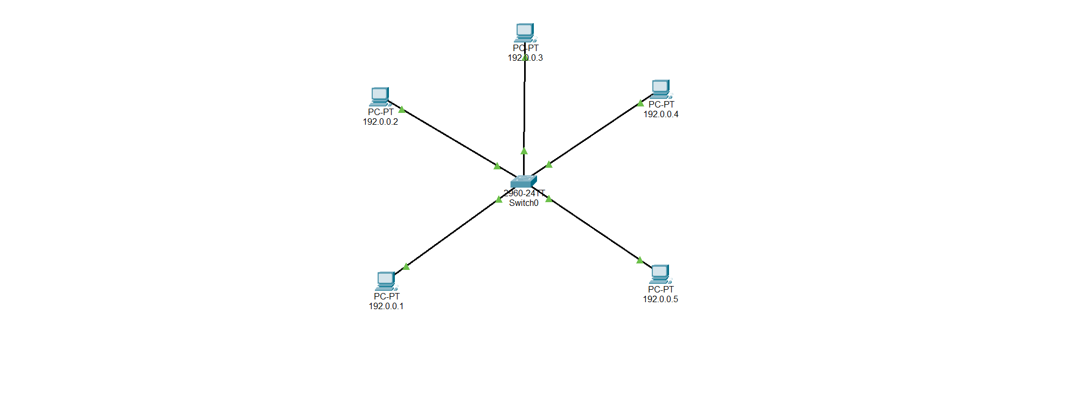

**Star Topology – Simulation**

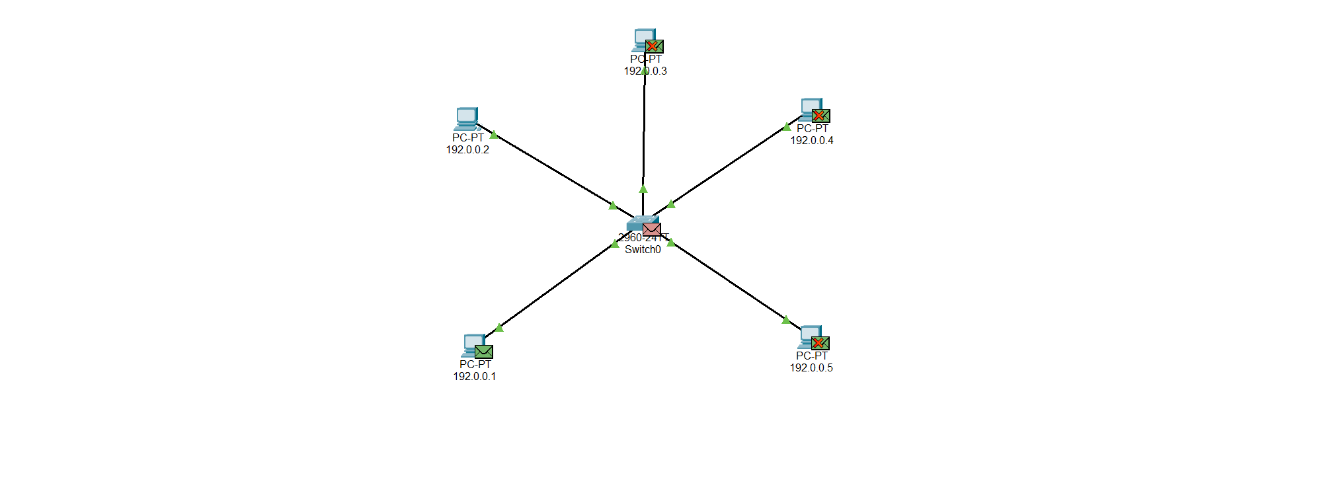

**Mesh topology**

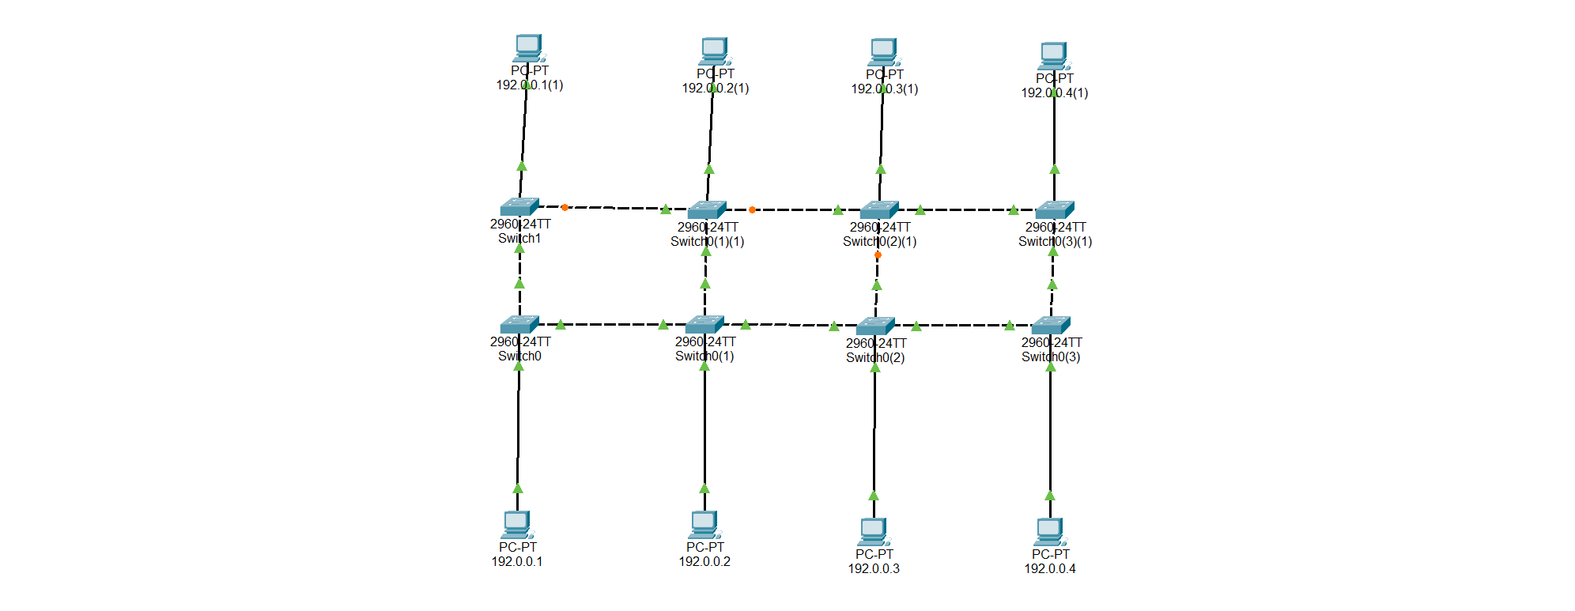

**Mesh topology – Simulation**

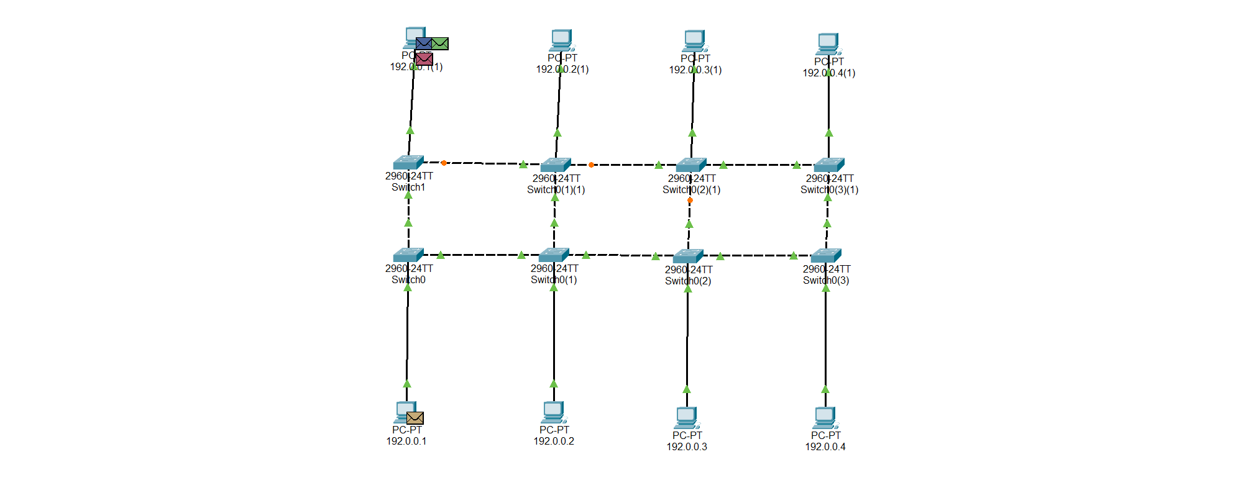

**Tree Topology**

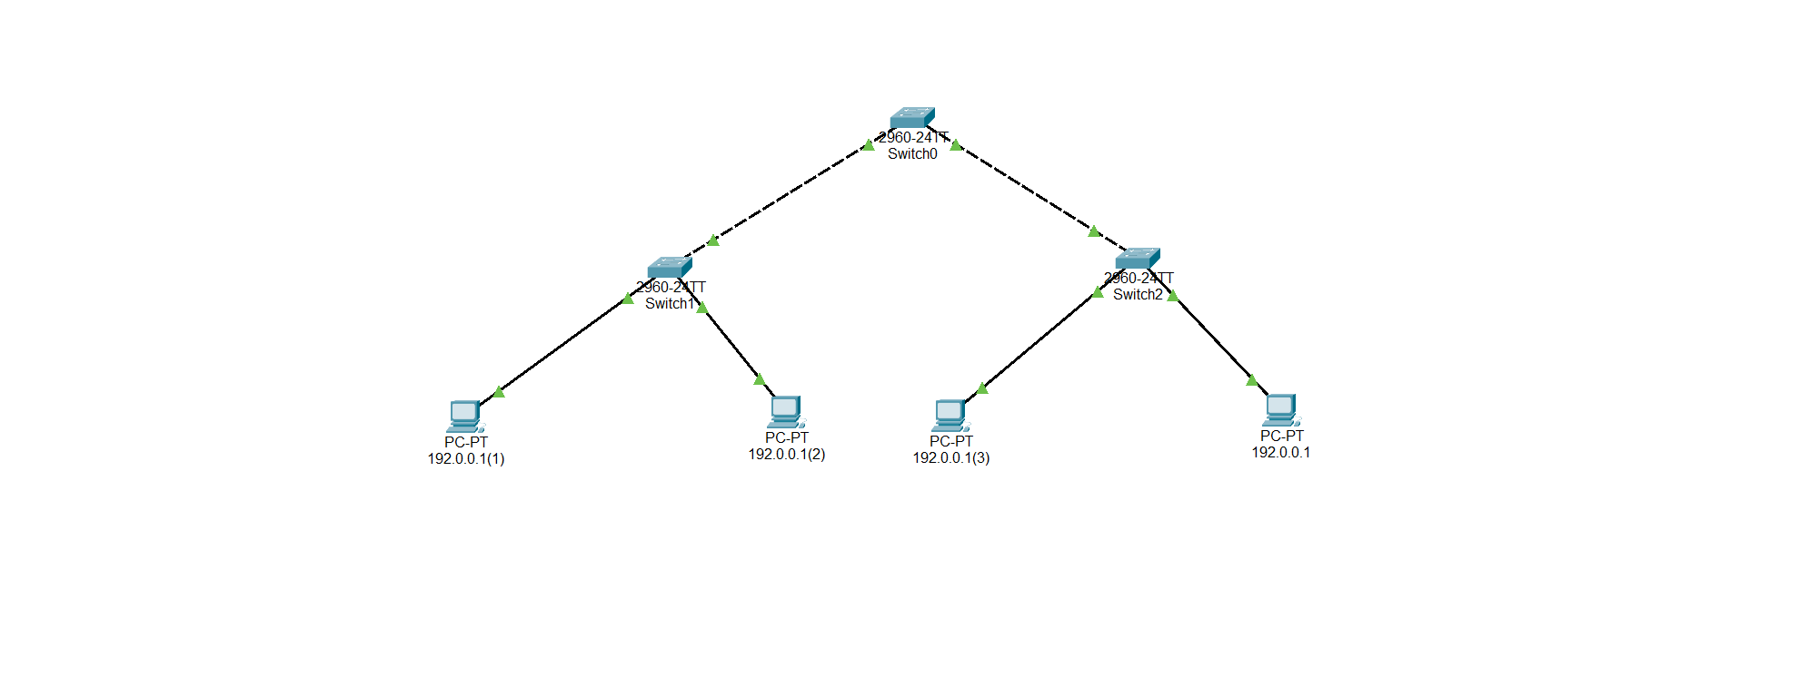

**Tree Topology – Simulation**

